NHB+
Organic Content Structures

Mindset

- All personal development, marketing, etc…is to change something
- Change something into something, become something we’re not
- There’s always two parts to the change process
  - 1. The thing that we want to become
    - Visualization
    - Vision boards
    - Goal setting
    - Mantras
    - Affirmations
    - All the good stuff
  - 2. The thing that prevents us from becoming
- All belief systems are nothing more than safety systems
- The question to ask is when did this thing get installed?
  - At what point in the timeline do you need to install the safety system?
  - When there is the greatest amount of CHANGE in your life
- If you want to get fire, you have to let wood burn, you gotta sacrifice the wood, and if you want to get heat, you have to let the fire die.
- You have to let go
- The 1st question is what do you have to let go? So you can become who you want to be?
  - Who do you have to let go, what do you have to let go?
- Close your eyes and go a year out from today:
  - It’s February 22nd, 2025 - and I have goal, and the reason I have gaol is because I let go and I accepted
  - Over the last year I let go of _________________
- Right now, in the present, how does not letting go of __________ serve and protect you?
- In the mind, there is always a subject and object relationship.
- An object influences the subject, and the subject responds / reacts to the object.
- Subject -> Object
- Subject —--------------------------- > Object
- Subject —-------------Relationship-------------- > Object
  - So the relationship part is INVISIBLE to us, and that is how it controls us
  - The greatest forces in nature are invisible
- Future you 1 year from now = object
- PResent you = subject
  - In between = RELATIONSHIP
- Relationship part has a shadow to it
  - Relationship has a PERCEPTION
  - Our relationship with ANYTHING including OUR future or PAST self is how we relate to it, and how we PERCEIVE it
  - You get a nice watch -> it’s an object, that you as a subject respond to -> how you relate to it is how you react / respond to it, and how you relate to it is how you perceive it
  - How does this perception serve us
  - And who are we to need to PERCEIVE this?
  - And if we let go of this perception, what are we afraid of perceiving and seeing?
    - This is what we are missing and our path forward.
- What can anyone possibly give me that I don’t have within?
- 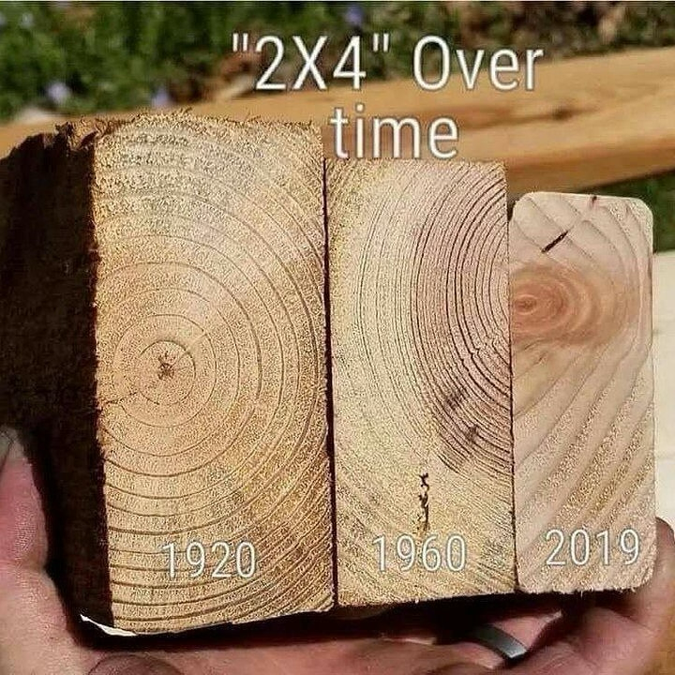
- Things that you’re holding on to, are holding you back.
- What do you need to let go?
- How are you letting go?
  - By observing it
- The only time you can let go is if it’s not part of you
- Why is there in the first place?
- Something happened in your life that gave you EXTRA protection around yourself
- The 1st step is to identify the structure
- If there is anything else that’s hiding in the shadows,
- There is FEAR in holding on.
  - Holding on is a FEAR based activity
  - Show me any evidence that I still may be holding on and RELEASE THAT EVIDENCE
  - So the mind will hold on to letting you know, hence more fear, a double protective mechanism
  - So it will hold on to letting you know what it’s holding on to
- The subconscious holds onto things of things that happened years ago, long ago, BECAUSE IT DOES NOT UNDERSTAND OR KNOW THAT TIME EXISTS, SO IT ACTS AS IF IT IS PRESENT, HENCE WHY IT DOES WHAT IT DOES IN THE PRESENT!!!!
  - That is the ONLY reason it can function like this, it’s devoid of TIME.
  - You are in the present, but the subconscious mind does not know time exists, so every point is a present, hence past creating PRESENT CONFLICT.
  - And the conflict and the battle between the conscious and the subconscious
  - This is how you get them aligned
  - And this is also why present based language works in the subconscious

Organic Content Structures

This is very important in dynamic markets, but less so in static markets.

Marketing is nothing more than change work.

For a long time we had different schools of thought in terms of marketing.

Paid vs Organic.

I’m in the paid side camp, but organic is really important to support the paid side.

So the paid layer started competing with organic layer.

It used to be paid vs paid.

This created a whole new problem.

Because what happens is that say you’re running on Youtube.

Even though organic does not scale, and organic does not translate into paid.

The cost of ads is going up, and the reason being is more and more people are getting into the game.

So it’s safe to assume that all things being equal, over the next 5 years, the cost of ads will triple.

What happens is there are only so many impressions available in the world, because we exist in the limitation of TIME.

Right now, everyone is thinking of CPA, then you got some people going for CLICKS, and then yet the biggest fish work on impressions.

Because the biggest fish, optimize for the biggest limitations.

You combine this with the algo and then well…you have a situation where a lot of people will get pruned out of the game and it becomes a winner takes all environment.

This happens everywhere. This winner takes all environment.

It happened in TV, Radio, Magazines, Direct Mail, etc…

You can see this is true based on the history of costs of these channels.

Inflation + competition = even higher prices.

Let's assume that the cost of ads will be 3-5x in 5 years.

If you have a nice lifestyle and a business, can you keep it if the costs double or triple?

Everything I’m doing here is to put you in the space of as if this is already happening, then when it does happen, it’s no big deal.

That’s why I developed the theory of competing on economics.

So paid goes up, we need support, which is organic.

Where the world is going now is that we are past the sales centric model of marketing.

Other have also transcended this.

Whenever you can transcend something, you beat that something else, because you become bigger than that which you transcended.

We are not acquiring customers, we are acquiring revenue, and that revenue is realized through relationship.

We’re entering the relationship era, so you're not generating conversions / sales. What you’re really generating are relationships.

Because your customers are a renewable source of revenue and out of that relationship you can generate as much revenue as you want, so long as it does not exceed 10% of their annual income.

So instead of day 0 money, we’re going into “money over time” models.

Banks, VCs, wall-street, etc…all big money is money over time models.

Really small companies focus on day 0 profits.

Small companies are day 0 money.

It’s hard to have day 0 money and relationships.

So relationships -> money over time = a lot of money.

Instead of day 0 ROAS, you’re at say Day 30 ROAS. The further you can extend this money over time, the more money you can make.

I had no audience, no one knew of me, and yet I built something that no other guru could build without spending a dollar on ads.

There is nobody in the industry that comes close to what I’ve done.

For example if you acquire say 1,000 today, and they give you money 8 months from now. Those customers at month 8 are generating your “today customers”.

Current Customers | Current Revenue | AOV | CPA
1,000 | At $97 a month = $97,000 | $50 | $100
 | You have a top level subsidy of $97,000 to help you break even.  $97,000 / 100 = 970 new customers | Break even | Break even
1,970 * $97 = $191090 | You have a top level subsidy of $191, 090 to help you break even.  $191,090 / 150 = 1,273 new customers | 50  Optimize your AOV | 150  Anatomy of Ads to lower CPA
3,243 * 97 = $314571 | You have a top level subsidy of $314,571 to help you break even.  $314571 / 200 = 1,572 new customers | 50 | 200
4, 815 customers | LTV = $300 over a year | $1,444,500

This is how ClickFunnels was built

After the relationship stage -> impressions stage.

You may have noticed me posting a lot more on social media lately, FB, Twitter, etc…I’m putting out A LOT more.

I’m moving into the impressions game.

I did the relationship for about 2 years, everyone copied me, and they did a shit job, and now i”m moving into generating impressions.

As you impress your name / brand into someone's mind, you’re creating neural imprinting.

You become an automatic reference point to the category.

Once you do this enough, you become a category of one.

I used to say “I want to take DK spot in the game”, “Nah, you got your own spot”.

Other people have done something similar, but they’ve lacked depth, so it’s surface level.

If you lack depth then what happens is that you become interchangeable.

Lack of depth doesn’t make them think or reflect.

The reason this key is…because you want them thinking about you when you’re not around.

When GV is not around yelling, very few people think about him and you can tell because he’s not a reference point in the game.

People don’t go “GV said that and that’s the way it is”.

You never hear people arguing and using him as a source of credibility in the argument.

Dan Kennedy = yes
Jay Abraham = yes
Chet Homles = yes
Alen Sultanic = yes

You have to pull them into an environment but also go to their environment.

The less energy they expand to consume your stuff, the more stuff they’ll consume.

#1 problem is these gurus “putting people in skool”.

A LOT of energy to consume.

Login values

The more people logged in, the higher the LTV.

Login frequencies

How many times a week do you log into skool vs facebook or twitter or YouTube?

Because Fb, Twitter and YouTube give you CHOICE, you don’t often come for the thing, you come for OTHER things and then you end up consuming the THING because your thing shows up.

All things being equal the human will always prefer choice and variety.

Go where they’re in flow energywise. Go where they’re spending energy.

Then once you do that, then you can isolate attention and then sell them.

In between that we use organic content structures.

Category of one

- Be different
- Be unique
- Be incomparable - this is the #1 advantage you can have today. If they can’t compare you to anyone, you’re in the category of one.

Deep vs shallow impressions

- What do they walk away with? If they walk away with motivation, that dissipates pretty quickly.

Who the audience is, that’s #1— then we can determine the type of content

Because who they are determines what we do.

I’m not talking about who they are as an audience in terms of entrepreneurs, etc…

I”m talking about Different types of followers:

- Entertainment follower
  - They’ll say and comment on things and like things
- Curiosity follower
  - Huge audiences, lower conversions
- Growth and learning follower
  - Smaller audiences, higher conversions
- Swipers
  - Don’t comment or engage unless they’re given something
- Bored
  - Not much engagement

Layer this with the 3 limiting beliefs

- Worthless (45%)
  - What & when & who
    - What is inspirational
      - Porsche 911
    - When is motivational
      - Expensive house
    - Who is hierarchical
      - Watch the equalizer call, conceptual God.
    - Example of worthless content

- 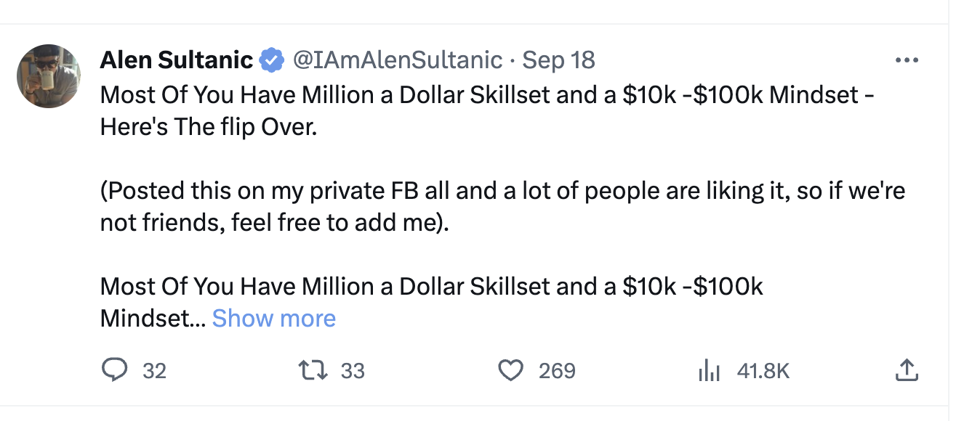
- 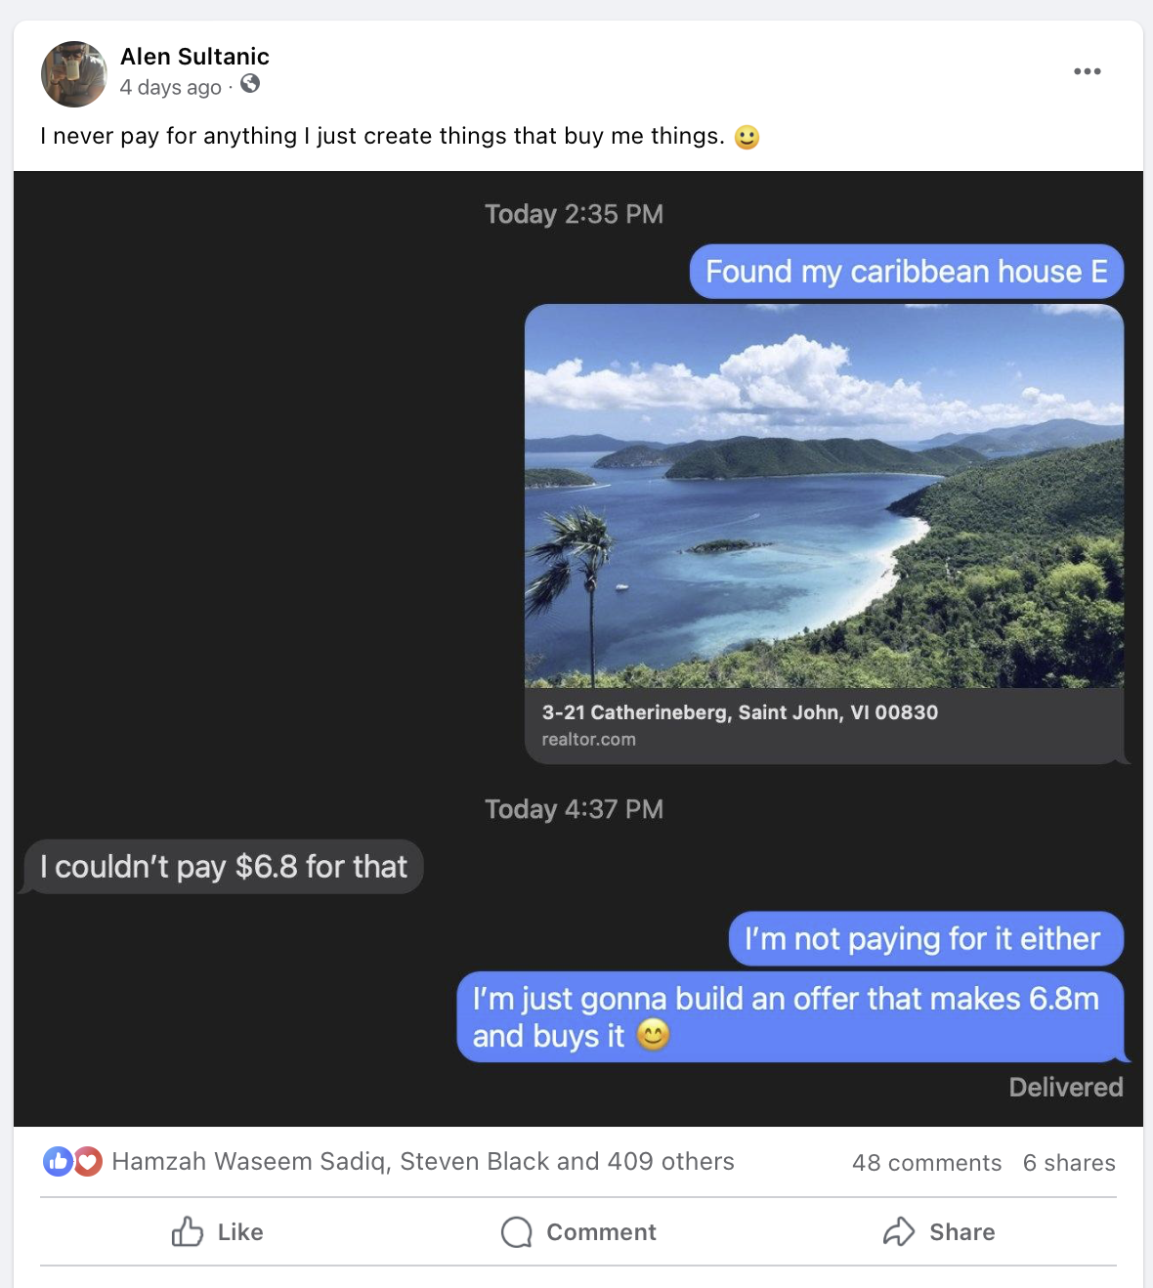
- Helpless (35%)
  - What & how content
  - What is inspirational
  - How is process and procedural

- 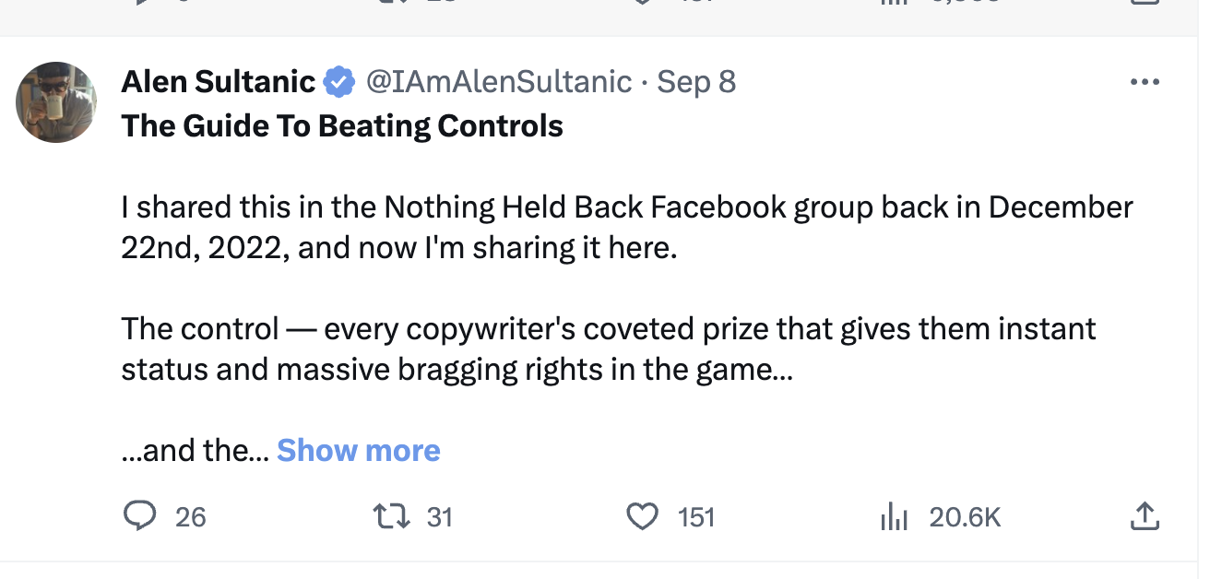

- Hopeless (20%)
  - Why & when and who, what

  - 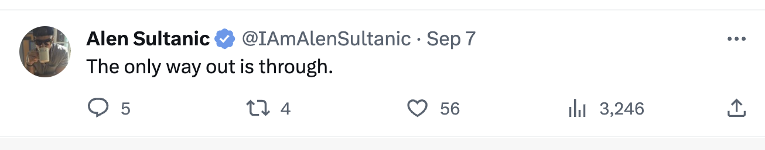

What you want to do is start categorizing on your own.

You can do shallow or deep posts. I do both because I just want to generate impressions.

The biggest thing with NHB is what constitutes a “HIGH VALUE POST”.

The sign of a high value post is if they walk away with answers or something they can use. That ultimately changes something for them. How they see things, what they can do, what they shouldn’t do, etc…

The more they walk with something you’ve given them, the more authority you have.

Parting gifts strategy.

These are subtle gifts that unconsciously get accepted.

If you look at all my posts, you’ll notice me doing this.

The sign of a low value post is if they walk away with questions.

When they walk away with questions, you create confusion and doubt and demonstrate your inability to articulate value, which subconsciously tells them you’re not really an expert.

You can see this happening in just about all the groups these days.

The only time they should walk away with questions is…thinking “I really don’t know all that much, I need to join their program so I can have a complete understanding”.

This allows me to create massive contrast in the marketplace.

There’s different types of content, and content means “the contents of something”.

That something has to go into something else.

Now, the only reason we want answers is because we have questions.

If we didn't have questions, then we would not engage with answers.

So therefore anyone engaging in your content has a question about it.

Note: Your content can threaten them, they’ll react to a threat. Be careful of threatening them.

All content is based around questions.

How, what, who, where, when, why

If your audience is process driven, they like step by step.

These forms of content are not mutually exclusive to each other, but rather can be interlinked to create a greater effect.

Why - reflective, it’s like a mirror, it’s deep understanding. This makes them feel safe and secure if they’re in a low emotional state. High-emotional state people generally do not like to read “why” content.

Why something works, why you did that, why others are doing it, why people are failing. You’re forcing reflection.

Typically, I’ll always have this.

This is the foundation of an argument, because if you can explain a real good why. They cannot challenge it.

So the absence of WHY tends to invite challenges.
- Why has the highest engagement, but lowest price elasticity.
- Why gives us safety. The bible is a lot of why.
- The why makes us feel complete inside.
- Human brains always have to have a reason as to WHY something is, and that’s WHY the WHY works, see how that just worked?
The way you say the way isn’t “here’s why it works”. “It works because ___________” or “the reason for this working is _________________”
Why stabilizes or destabilizes emotions. Based on your POV shift you can make them stable or unstable.
Why are my campaigns failing? The answer can be stabilizing or destabilizing. Your business is done or finished or it’s growing, it’s going.
Think of the content structure as an invisible grid that holds the thoughts.
When - is motivational - when _______ then you will.
If you notice me writing copy or anything, you’ll see me saying “and when you do this, you’ll ______________ (outcome), and then ________________.
Once and when are interchangeable.
How do you motivate kids? When you eat your veggies, you’ll (reward).
How do kids anticipate high emotional payoffs: “When are we going to _______________”.
Because all payoffs are in the future.
And also WHEN can be very demotivating as well. When that happens (bad things happen). So you can use WHEN to motivate or demotivate them.
If you notice what I just said to Brad…”What happens when 50,000 new chiros come out of school and 3 open down the road from you at half the price?” In this thought, I forced the why.
When sets the expectation which generates hope, optimism, pessimism.
What - is inspirational - “What you will do and what will happen once you do it” Notice the difference in choice of words ONCE and WHEN.

What is an object in the mind? It’s a 3d shape, it’s something they can tangibly visualize.

You’re generating images.

What your potential is, what you’re capable of.

This is an imagine.

What you need to do is ______________________.

An image can be close, or far, or somehow related to the things in the mind.

How - is educational and procedural
- How to content has the highest price elasticity, but lowest engagement.
- This gives them certainty of understanding how something works, but should come after the what, when, and why.
- So most people will say “here’s how you do it”, why do I need to do that? What do I need to do? When do I need to do it? Is this the right time to do it?
Who - hierarchical / positioning
- This opens a connection between two people, it’s the relational question
- Who’s doing it, who’s not doing it
- Who can do it, who can’t do it
- This identifies, position and moves and sets up the relationship in the mind
- It should always have someone they know
- If you have someone who they don’t know, they can’t relate to it
Where - this orients them, creates a position out of which direction can be created

- Without a where, you can’t create a direction
- If you can’t create a direction, then you can’t really move them into the direction you want
- So physical where and a psychological where
- I mostly focus on the psychological
- Where is your business at?
- Where are you at?
- Where is your business in your area at?
- We use where to help them FIND things
- Without this, they can’t find anything.
Why - opens to the past
How - opens to the process
What - opens to things
Who - opens to connection
When - opens to time
Where - opens to location
The symbolic meaning of a question is the unknown in the mind
  - Why - mirror in the past
  - How - process
  - What - specific thing that we are focused on. What is the specific object?
  - When - point in time
  - Where - Point in space
  - Who - the person
Example Post #1
The What
The #1 thing I see everywhere now is "fatigue", and that's going to be the biggest friction point in time to come.
The Why
As technology allows us to create more easily and removes limitations, the more choices we have and thus, the more decisions we have to make.
There's only so much we can consume at any given moment and when we hit peak levels of consumption, fatigue of consumption kicks in.
The Where
I'm seeing it everywhere, from personal to offers, to content creators.

The Who
"Guru fatigue" is getting real bad and you can see it in how people are openly starting to shit on them.
Personally, I used to be big into conspiracy theories, but these days...the fatigue of conspiracy theories has reached its peak and I haven't even looked into it in quite a while, just don't care anymore.
There are other areas as well, and as for the people I'm mentoring, the undertone of dating offers is touching dating fatigue, which is a real thing in the real world.
It's happening across the board from biz-op, to weight loss, to dating, to survival.
The Why and When
Pay attention to fatigue, and you'll notice it everywhere, it creates this sluggish movement of audiences.
Fatigue is generated from the same emotions being generated in the audience without analog emotions to offset and rebalance them.
Whereas before they wanted to expand energy, now they do so because they have to, that's a big difference and it's everywhere...and the #1 way to combat fatigue is through simplification.
The How
I have a mental model I use in everything, which is to maximize, minimize, and simplify.
Maximize outcomes, minimize effort and inputs to get the outcomes, and simplify the process.
Using this mental model allows me to side-step fatigue in my work and reduce it for them and thus opening up audiences to more possibilities.
Once you know how to open them up to possibilities, then you've created an "open-minded" customer, who is also a "changeable" customer, and it's a lot more difficult to sell anything without them being open-minded and changeable.
- Alen
The reason I end up in the HOW is because the HOW without the context isn’t useful.
So I say to Idan, here's how to make this drink.
Vs.
Hey Idan, when you goto a marketing event, the best way to connect with people is to learn to make drinks and celebrate together, here's how you make the best one everyone will love.
Example Post #2
The What
We're At The A.I. Saturation Point & The Hype Wave Is Over
Having built 4 of the biggest A.I. offers in the industry and looking at the data day in day out — I can safely tell you that we're already at an A.I. saturation point and the hype wave is over.
The Why
The audience isn't "biting" like they were a few months ago. The CPAs are up and AOVs are down.
They're still good to use but they're no longer infatuated by it.
The When
So going fwd, A.I. offers will be harder to convert than before, so I wouldn't go "OMFG, we'll just add "A.I. to it and it'll crush". Trust me, it won't.
The How
Go back to basics, principles and philosophies, that'll take you the distance.
This goes back to one of my principles when it comes to competitive advantages...
...if everyone is doing the same thing, then everyone has the same advantages, and when everyone has the same advantages, they become disadvantages.
This is the primary reason why I teach people to think, so they can create their own models and have their own unique advantages that no one else has. It's the only way to win and keep your wins.
You can have horizontal or vertical change
Example Post #3
The How - The audience already knew what copy claims were, so I could get to the point
How To Create Copy Claim Chains In The Mind
The What
As the game changes and market sophistication increases, one of the ways we tend to compete is by increasing the claims in copy.
The Why
The problem of competing on claims is that at some point, someone will start lying and the only way to compete with liars is to become a better liar, so here's a better, more honest and more effective way to compete and win on claims without ever lying, always telling the truth and keeping your integrity.
The best lines in copy allow them to make the claims, because their claims are always going to be stronger than your claims.
The reason being is a claim is never a claim. A claim is just a starting point of many other claims. One claim results in many claims in the mind. One claim forms a chain of claims, the longer the chain created, the stronger your initial claim is.
The Who
Unless you know the audience inside out, you'll rarely know the chain of claims, so to overcome this, we can use lines that allow THEM to make the claims which create chains of claims.
The How
Here’s one of my favorites I use all the time in biz-op:
“We’ll show you how to make it, and how much you make is up to you.”
Modified for weight loss:
“We’ll show you how to lose weight, and how much and how fast you want to lose is up to you.”
Modified for dating:
“We’ll show you how to meet _________, and how many dates you go on and what happens after those dates is up to you”.
You can have a few modifiers on the first line, such as “This will allow you to”, “this will show you”, “You’ll discover”, etc…
What this does is starts the initial claim and then "the rest is up to you", well of course...it's always up to them, but this allows them to create claim chains deep in the mind by taking them into the realm of possibility, attainability. They self-hypnotize with this.
Play with it, put it in your copy and notice what it does to the whole copy.
- Alen
p.s. Doesn't hurt that it also helps keep copy very compliant while carrying the punch throughout.

What you’ll notice most people doing is they’ll do these posts but only answer one question, and they feel very one dimensional, they lack depth.
So the depth can be also measured by the amount of questions answered.
If you can answer all 6 questions in a post, then your post will feel “complete”.
If you don’t, then it will feel empty and incomplete.
Expertise is measured by how deep you can go into the topic.
Gender weights depth scale
Question | Men | Women
Why | Very Important | Important
What | Very Important | Very important
How | Very important | Somewhat important
Where | Important | Important
Who | Somewhat important | Very important
When | Important | Very important
If you write posts without this mix and you don’t have 2 or 3 out of the 6, then they’ll fill it in themselves.
If they fill in the samples, they’ll typically fill it in with what keeps them safe and secure and it won’t be in your favor.
All content that I do starts with WHAT and ends in HOW.
Because What - is inspirational - “What you will do and what will happen once you do it” Notice the difference in choice of words ONCE and WHEN.
To inspire means that they can do it too. Inside, to grow from within.
Ends up in HOW so that they can do it too, it COMPLETES THE LOOP.
My content does not have open loops.
The other thing to do in the content is also to focus on how it’s different. So the “what” should stand out.
To separate yourself from anything else.
One last thing — this can be used in posts, emails, calls, chats, whatever.
I’ll do a wave form pattern where it’s like 1 low volume post, 2-3 medium and 1 long.
In between I”m creating impressions.
“What are we talking about today?”
That’s the start of your post
How do they do it? That’s the end of your post.
In between is everything else.
What you’ll notice is that your content now has a PUNCH.
For high emotional and low
High emotional = the depth of the how. They only care about how it works.
The reason these emails work is because __________ unlike other emails.
Low emotional people = need deeper why as to why it didn’t work for them and why this will work for them. So in a sense a DOUBLE why. Why it happened and WHY it’ll work. A double level of security.

